모바일프로그래밍 과제13 컴퓨터소프트웨어공학과 2-YA 20202296 전채린

실습 12-1 가수 그룹 관리 DB 만들기

[소스코드]

activity_main.xml

<?xml version="1.0" encoding="utf-8"?>  
<LinearLayout xmlns:android="http://schemas.android.com/apk/res/android"  
 xmlns:app="http://schemas.android.com/apk/res-auto"  
 xmlns:tools="http://schemas.android.com/tools"  
 android:layout_width="match_parent"  
 android:layout_height="match_parent"  
 android:orientation="vertical"  
 tools:context=".MainActivity">  
  
 /* 실습12-2 가수 그룹 관리 DB 만들기  
 가수 그룹의 이름과 인원을 데이터베이스에 입력하고 조회하는 응용 프로그램 작성 */  
 /* activity_main.xml */  
  
 <TextView  
 android:layout_width="match_parent"  
 android:layout_height="wrap_content"  
 android:text="20202296 전채린" />  
 <LinearLayout  
 android:layout_width="fill_parent"  
 android:layout_height="0dip"  
 android:layout_weight="1"  
 android:orientation="horizontal" >  
 <TextView  
 android:layout_width="wrap_content"  
 android:layout_height="wrap_content"  
 android:text="이름 : "  
 android:textSize="20dp" />  
 <EditText  
 android:layout_width="wrap_content"  
 android:layout_height="wrap_content"  
 android:id="@+id/edtName"  
 android:text="가수 이름을 입력하세요."  
 android:layout_weight="1" />  
 </LinearLayout>  
 <LinearLayout  
 android:layout_width="fill_parent"  
 android:layout_height="0dip"  
 android:layout_weight="1"  
 android:orientation="horizontal" >  
 <TextView  
 android:layout_width="wrap_content"  
 android:layout_height="wrap_content"  
 android:text="인원 : "  
 android:textSize="20dp" />  
 <EditText  
 android:layout_width="wrap_content"  
 android:layout_height="wrap_content"  
 android:id="@+id/edtNumber"  
 android:text="가수 인원을 입력하세요."  
 android:layout_weight="1" />  
 </LinearLayout>  
 <LinearLayout  
 android:layout_width="fill_parent"  
 android:layout_height="0dip"  
 android:layout_weight="1"  
 android:orientation="horizontal" >  
 <Button  
 android:layout_width="wrap_content"  
 android:layout_height="wrap_content"  
 android:id="@+id/btnInit"  
 android:text="초기화" />  
 <Button  
 android:layout_width="wrap_content"  
 android:layout_height="wrap_content"  
 android:id="@+id/btnInsert"  
 android:text="입력" />  
 <Button  
 android:layout_width="wrap_content"  
 android:layout_height="wrap_content"  
 android:id="@+id/btnSelect"  
 android:text="조회" />  
 </LinearLayout>  
 <LinearLayout  
 android:layout_width="fill_parent"  
 android:layout_height="0dip"  
 android:layout_weight="8"  
 android:orientation="horizontal" >  
 <EditText  
 android:layout_width="wrap_content"  
 android:layout_height="match_parent"  
 android:id="@+id/edtNameResult"  
 android:layout_weight="1"  
 android:background="#00FF00"  
 android:padding="20dp" />  
 <EditText  
 android:layout_width="wrap_content"  
 android:layout_height="match_parent"  
 android:id="@+id/edtNumberResult"  
 android:layout_weight="1"  
 android:background="#00FF00"  
 android:padding="20dp" />  
 </LinearLayout>  
</LinearLayout>

MainActivity.kt

package aca.hankook.project12_1  
  
import android.database.sqlite.SQLiteDatabase  
import androidx.appcompat.app.AppCompatActivity  
import android.os.Bundle  
import android.widget.Toast  
import kotlinx.android.synthetic.main.activity_main.*  
  
class MainActivity : AppCompatActivity() {  
  
 override fun onCreate(savedInstanceState: Bundle?) {  
 super.onCreate(savedInstanceState)  
 setContentView(R.layout.*activity_main*)  
  
 /* 예제12-4 Kotlin 코드 3 */  
 *title* = "가수 그룹 관리 DB"  
  
 var myDBHelper = MyDBHelper(this)  
 var sqlDB: SQLiteDatabase  
  
 /* 예제12-5 Kotlin 코드 4 */  
 btnInit.setOnClickListener **{** sqlDB = myDBHelper.*writableDatabase* myDBHelper.onUpgrade(sqlDB, 1, 2)  
 sqlDB.close()  
 btnSelect.callOnClick()  
 **}** /* 예제12-6 Kotlin 코드 5 */  
 btnInsert.setOnClickListener **{** sqlDB = myDBHelper.*writableDatabase* var name = edtName.*text*.toString()  
 var number = edtNumber.*text*.toString().*toInt*()  
 sqlDB.execSQL("insert into groupTBL values ('$name', $number);")  
 sqlDB.close()  
 Toast.makeText(*applicationContext*, "입력됨", Toast.*LENGTH_LONG*).show()  
 edtName.setText("")  
 edtNumber.setText("")  
 btnSelect.callOnClick()  
 **}** btnSelect.setOnClickListener **{** sqlDB = myDBHelper.*readableDatabase* var cursor = sqlDB.rawQuery("select * from groupTBL;", null)  
  
 var strName : String = "그룹이름" + "\r\n" + "--------------------------------" + "\r\n"  
 var strNumber : String = "인 원" + "\r\n" + "--------------------------------" + "\r\n"  
 while (cursor.moveToNext()) {  
 strName += cursor.getString(0) + "\r\n"  
 strNumber += cursor.getString(1) + "\r\n"  
 }  
  
 edtNameResult.setText(strName)  
 edtNumberResult.setText(strNumber)  
 sqlDB.close()  
 **}** }  
}

MyDBHelper.kt

package aca.hankook.project12_1  
  
import android.content.Context  
import android.database.sqlite.SQLiteDatabase  
import android.database.sqlite.SQLiteOpenHelper  
  
/* 예제12-2 Kotlin 코드 1 */  
class MyDBHelper(context: Context) : SQLiteOpenHelper(context, "groupDB", null, 1) {  
  
 /* 예제12-3 Kotlin 코드 2 */  
 override fun onCreate(p0: SQLiteDatabase?) {  
 var tableCreSql = "CREATE TABLE groupTBL(gName CHAR(20) PRIMARY KEY, gNumber INTEGER);"  
 p0!!.execSQL(tableCreSql)  
 }  
  
 override fun onUpgrade(p0: SQLiteDatabase?, p1: Int, p2: Int) {  
 p0!!.execSQL("DROP TABLE if EXISTS groupTBL")  
 onCreate(p0)  
 }  
}

[실행결과]

1) 초기화면

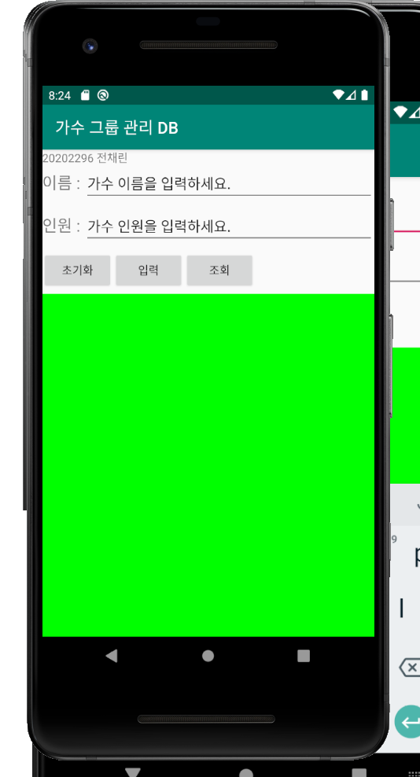

2) 입력 화면

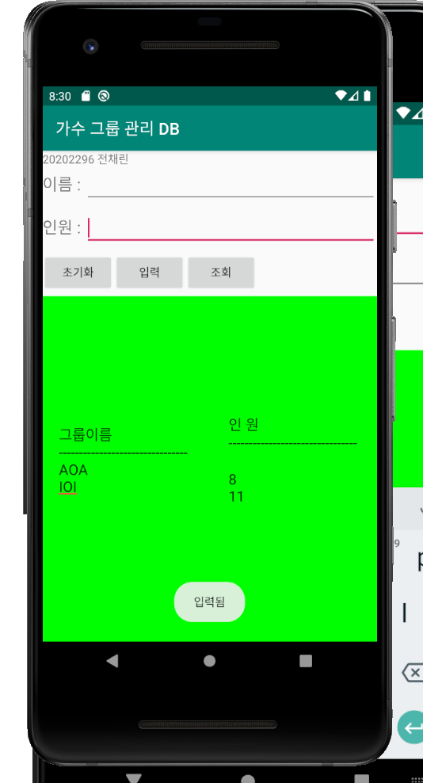

2) 조회 화면

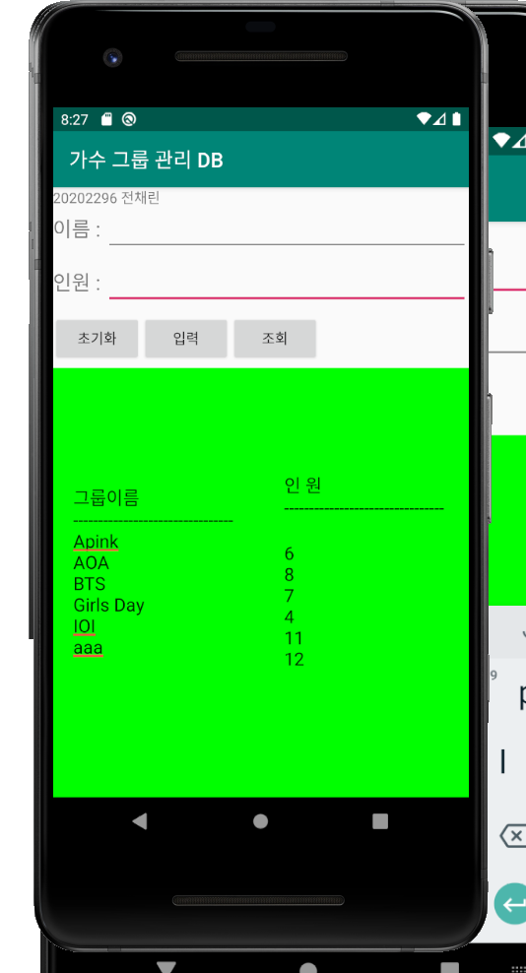

3) 초기화 화면

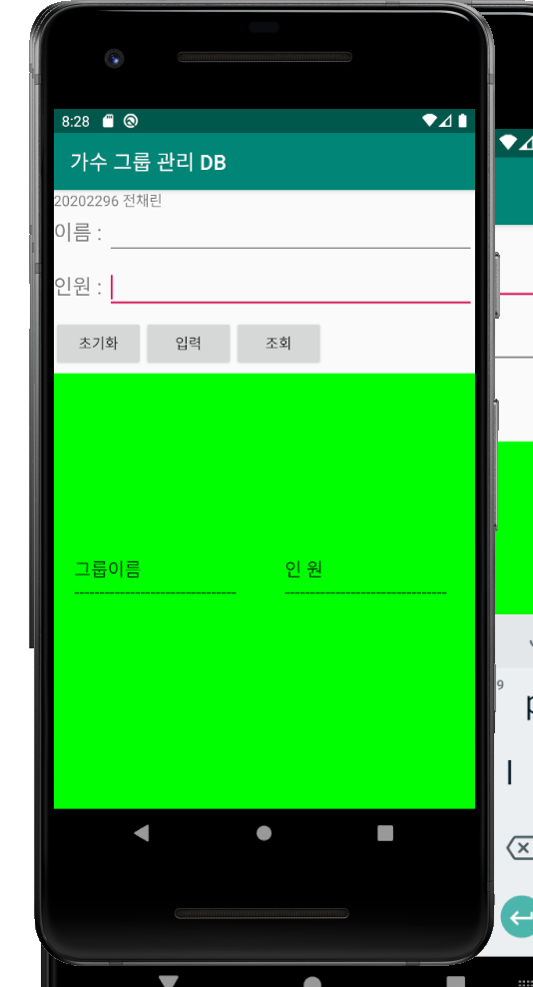

CustomListViewEx 학생 목록 예제

[소스코드]

activity_main.xml

<?xml version="1.0" encoding="utf-8"?>  
<LinearLayout xmlns:android="http://schemas.android.com/apk/res/android"  
 xmlns:app="http://schemas.android.com/apk/res-auto"  
 xmlns:tools="http://schemas.android.com/tools"  
 android:layout_width="match_parent"  
 android:layout_height="match_parent"  
 android:orientation="vertical"  
 tools:context=".MainActivity">  
  
 /* CustomListViewEx  
 activity_main.xml */  
 <TextView  
 android:layout_width="wrap_content"  
 android:layout_height="wrap_content"  
 android:text="20202296 전채린" />  
 <ListView  
 android:layout_width="match_parent"  
 android:layout_height="wrap_content"  
 android:id="@+id/listView1" />  
</LinearLayout>

rowitem.xml

<?xml version="1.0" encoding="utf-8"?>  
<LinearLayout xmlns:android="http://schemas.android.com/apk/res/android"  
 android:orientation="horizontal" android:layout_width="match_parent"  
 android:layout_height="match_parent">  
 <ImageView  
 android:layout_width="110dp"  
 android:layout_height="80dp"  
 android:id="@+id/itemImage" />  
 <LinearLayout  
 android:layout_width="wrap_content"  
 android:layout_height="wrap_content"  
 android:orientation="vertical" >  
 <TextView  
 android:layout_width="wrap_content"  
 android:layout_height="wrap_content"  
 android:id="@+id/itemName"  
 android:textSize="20sp"  
 android:textColor="#ff0000"  
 android:text="이름" />  
 <TextView  
 android:layout_width="wrap_content"  
 android:layout_height="wrap_content"  
 android:id="@+id/itemDept"  
 android:textSize="15sp"  
 android:textColor="#00ff00"  
 android:text="소속학과" />  
 <TextView  
 android:layout_width="wrap_content"  
 android:layout_height="wrap_content"  
 android:id="@+id/itemId"  
 android:textSize="10sp"  
 android:text="학생번호" />  
 </LinearLayout>  
</LinearLayout>

jasehi.xml

<?xml version="1.0" encoding="utf-8"?>  
<LinearLayout xmlns:android="http://schemas.android.com/apk/res/android"  
 xmlns:app="http://schemas.android.com/apk/res-auto"  
 xmlns:tools="http://schemas.android.com/tools"  
 android:layout_width="match_parent"  
 android:layout_height="match_parent"  
 android:orientation="vertical"  
 tools:context=".JasehiActivity">  
 <TextView  
 android:layout_width="match_parent"  
 android:layout_height="wrap_content"  
 android:id="@+id/jName"  
 android:textSize="20sp"  
 android:textColor="#0048FF"  
 android:text="학생 상세 설명" />  
 <TextView  
 android:layout_width="match_parent"  
 android:layout_height="wrap_content"  
 android:id="@+id/jid"  
 android:text="학생번호" />  
 <TextView  
 android:layout_width="match_parent"  
 android:layout_height="wrap_content"  
 android:text="[봉사활동]" />  
 <TextView  
 android:layout_width="match_parent"  
 android:layout_height="wrap_content"  
 android:id="@+id/jHdong1"  
 android:text="봉사활동내역" />  
 <TextView  
 android:layout_width="match_parent"  
 android:layout_height="wrap_content"  
 android:text="[창의적 체험활동]" />  
 <TextView  
 android:layout_width="match_parent"  
 android:layout_height="wrap_content"  
 android:id="@+id/jHdong2"  
 android:text="창의적체험활동" />  
</LinearLayout>

MainActivity.kt

package aca.hankook.customlistviewex  
  
import android.content.Intent  
import android.database.Cursor  
import android.database.sqlite.SQLiteDatabase  
import androidx.appcompat.app.AppCompatActivity  
import android.os.Bundle  
import android.widget.Toast  
import kotlinx.android.synthetic.main.activity_main.*  
  
  
class MainActivity : AppCompatActivity() {  
  
 override fun onCreate(savedInstanceState: Bundle?) {  
 super.onCreate(savedInstanceState)  
 setContentView(R.layout.*activity_main*)  
  
 var studentList : ArrayList<StudentC> = *arrayListOf*<StudentC>()  
 /*  
 studentList.add(StudentC("2101", "배수지", "멀티미디어과", "s2101", "배우겸가수", "스타트업 드라마"))  
 studentList.add(StudentC("2102", "한지민", "컴퓨터소프트웨어과", "s2101", "배우", "영화"))  
 studentList.add(StudentC("2103", "남주혁", "스타트업과", "s2101", "배우", "영화 및 드라마"))  
 */  
  
 var myHelper = MyDBHelper(this)  
 var sqlDB : SQLiteDatabase = myHelper.*readableDatabase* var cursor : Cursor = sqlDB.rawQuery("select * from studentTBL", null)  
 while (cursor.moveToNext()) {  
 studentList.add(StudentC(cursor.getString(0), cursor.getString(1), cursor.getString(2), cursor.getString(3), cursor.getString(4), cursor.getString(5)))  
 }  
 cursor.close()  
 sqlDB.close()  
  
 var adapter1 = ListViewAdapter(studentList)  
 listView1.*adapter* = adapter1  
  
 listView1.setOnItemClickListener **{** adapterView, view, i, l **->** Toast.makeText(*applicationContext*, studentList.get(i).name, Toast.*LENGTH_LONG*).show()  
  
 var intent1 = Intent(*applicationContext*, JasehiActivity::class.*java*)  
  
 intent1.putExtra("name", studentList.get(i).name)  
 intent1.putExtra("id", studentList.get(i).id)  
 intent1.putExtra("hdong1", studentList.get(i).hdong1)  
 intent1.putExtra("hdong2", studentList.get(i).hdong2)  
 startActivity(intent1)  
 **}** }  
}

StudentC.kt

package aca.hankook.customlistviewex  
  
class StudentC(var id: String, var name : String, var dept : String, var sajin : String, var hdong1: String, var hdong2: String) {}

ListViewAdapter.kt

package aca.hankook.customlistviewex  
  
import android.view.View  
import android.view.ViewGroup  
import android.widget.BaseAdapter  
import kotlinx.android.synthetic.main.rowitem.view.*  
  
class ListViewAdapter(var studentList : ArrayList<StudentC>) : BaseAdapter() {  
 override fun getView(p0: Int, p1: View?, p2: ViewGroup?): View {  
 var rowItemView = p1  
  
 if(rowItemView == null) {  
 rowItemView = View.inflate(p2?.*context*, R.layout.*rowitem*, null)  
 }  
  
 val student : StudentC = studentList[p0]  
 var sajinResid:Int = p2!!.*resources*.getIdentifier("aca.hankook.customlistviewex:" + "drawable/" + student.sajin, null, null)  
 rowItemView!!.itemImage.setImageResource(sajinResid)  
 rowItemView.itemName.*text* = student.name  
 rowItemView.itemDept.*text* = student.dept  
 rowItemView.itemId.*text* = student.id.toString()  
  
 return rowItemView  
 }  
  
 override fun getItem(p0: Int): Any {  
 return studentList[p0]  
 }  
  
 override fun getItemId(p0: Int): Long {  
 return p0.toLong()  
 }  
  
 override fun getCount(): Int {  
 return studentList.size  
 }  
  
}

JasehiActivity.kt

package aca.hankook.customlistviewex  
  
import android.content.Intent  
import androidx.appcompat.app.AppCompatActivity  
import android.os.Bundle  
import kotlinx.android.synthetic.main.jasehi.*  
  
class JasehiActivity : AppCompatActivity() {  
  
 override fun onCreate(savedInstanceState: Bundle?) {  
 super.onCreate(savedInstanceState)  
 setContentView(R.layout.*jasehi*)  
  
 var intent1 : Intent = *intent* var name : String? = intent1.getStringExtra("name")  
 var id : String? = intent1.getStringExtra("id")  
 var hdong1 : String? = intent1.getStringExtra("hdong1")  
 var hdong2 : String? = intent1.getStringExtra("hdong2")  
  
 jid.*text* = id  
 jName.*text* = name  
 jHdong1.*text* = hdong1  
 jHdong2.*text* = hdong2  
 }  
}

MyDBHelper.kt

package aca.hankook.customlistviewex  
  
import android.content.Context  
import android.database.sqlite.SQLiteDatabase  
import android.database.sqlite.SQLiteOpenHelper  
  
class MyDBHelper(context: Context) : SQLiteOpenHelper(context, "studentDB", null, 1) {  
 override fun onCreate(p0: SQLiteDatabase?) {  
 var tableCreSql = "create table studentTBL (id char(4) primary key, name varchar(20), dept varchar(20), sajin varchar(5), hdong1 varchar(200), hdong2 varchar(600));"  
 p0!!.execSQL(tableCreSql)  
 p0!!.execSQL("insert into studentTBL values('2101', '배수지', '멀티미디어과', 's2101', '대한민국의 가수겸배우', 'missA 멤버로 데뷔, 영화<건축학개론>으로 스타덤에 오름')")  
 p0!!.execSQL("insert into studentTBL values('2102', '한지민', '컴퓨터소프트웨어과', 's2102', '활동1', '활동2')")  
 p0!!.execSQL("insert into studentTBL values('2103', '남주혁', '스타트업과', 's2103', '대한민국의 모델이자 배우', '경남중학교 농구선수로 활동하다 모델을 해보라고 말했던 걸 기억했고 모델이 됨')")  
 p0!!.execSQL("insert into studentTBL values('2201', '조정석', '간담췌외과', 's2201', '대한민국의 뮤지컬 배우 출신', '연기가 본업, 예능방송, 음반활동')")  
 p0!!.execSQL("insert into studentTBL values('2202', '유연석', '소아외과', 's2202', '대한민국배우', '활동2')")  
 p0!!.execSQL("insert into studentTBL values('2203', '정경호', '흉부외과', 's2203', '활동1', '활동2')")  
 p0!!.execSQL("insert into studentTBL values('2301', '김대명', '산부인과', 's2301', '활동1', '활동2')")  
 p0!!.execSQL("insert into studentTBL values('2302', '전미도', '신경외과', 's2302', '활동1', '활동2')")  
 }  
  
 override fun onUpgrade(p0: SQLiteDatabase?, p1: Int, p2: Int) {  
 p0!!.execSQL("drop table if exists studentTBL")  
 onCreate(p0)  
 }  
  
}

[실행결과]

1) 초기화면

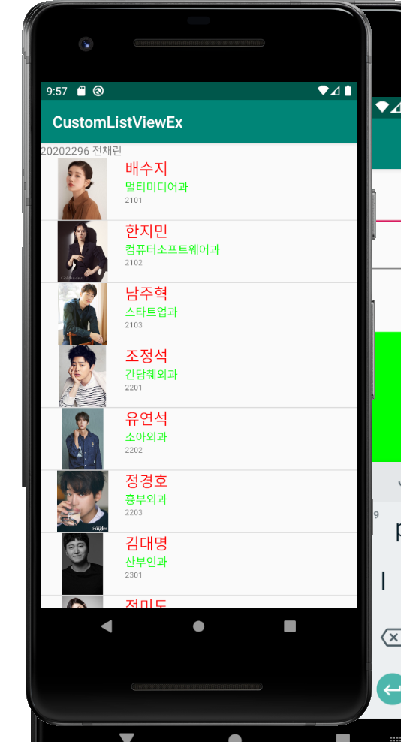

2) 배수지 선택 화면

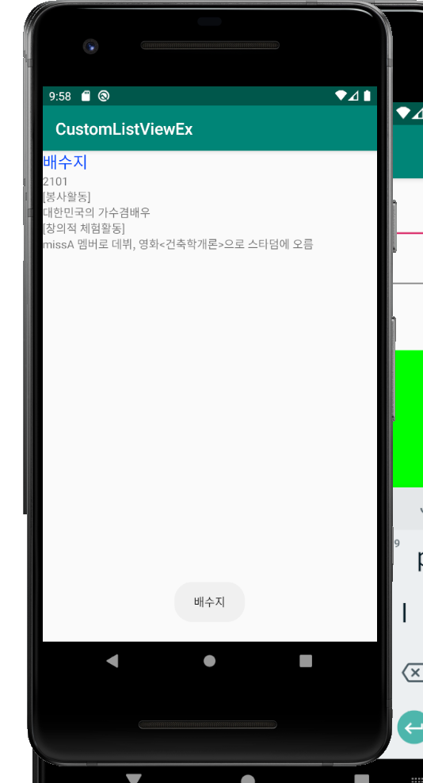

2) 조정석 선택 화면

